**The Cell 1**

**STRUCTURES OF PLANT AND ANIMAL CELLS**  
Plant and animal cells share many organelles, like ribosomes and mitochondria, but also have unique ones, plant cells have cell walls, while animal cells have centrioles.

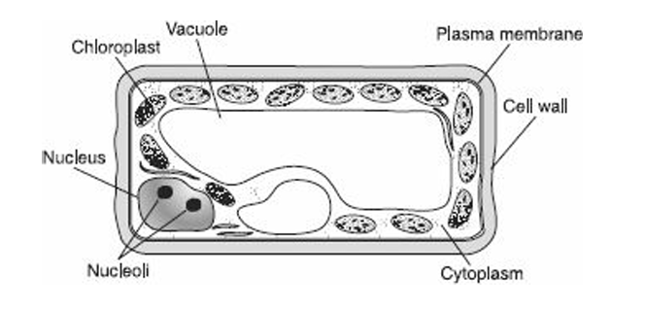

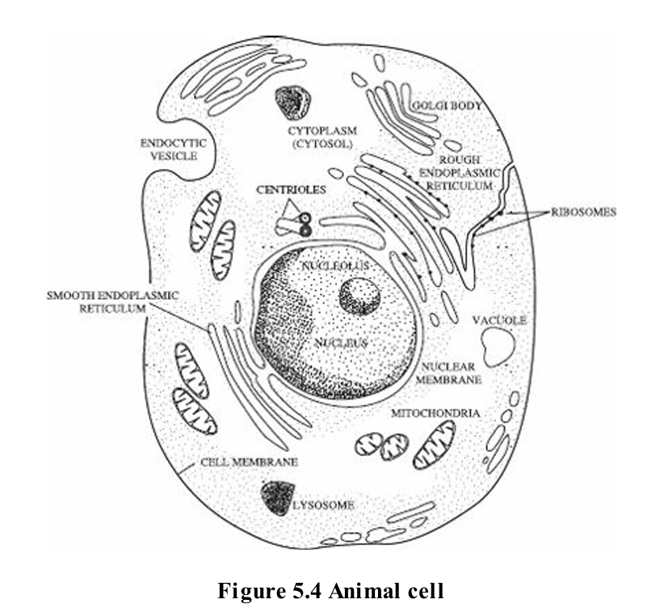

**DR SALMA KHALED BIOLOGY EDUCATOR**

**Nucleus**  
The nucleus contains chromosomes made of DNA wrapped with special proteins called histones into a chromatin network. Chromosomes contain genes, bits of DNA that code for polypeptides. The nucleus is surrounded by a selectively permeable double membrane (nuclear envelope) with pores that allow large molecules such as RNA to move out into the cytoplasm.

**Nucleolus**  
A prominent region inside a non-dividing nucleus where ribosome components are synthesized. Nucleoli are not membrane-bound but are tangles of chromatin and unfinished ribosome parts. Usually, one or two nucleoli are visible in a non-dividing cell.

**Ribosome**  
The site of protein synthesis, made of ribosomal RNA and protein. Ribosomes can be free in the cytoplasm or attached to the endoplasmic reticulum. Cells producing large amounts of protein (e.g., human liver cells) may contain millions of ribosomes.

**Endoplasmic Reticulum (ER)**  
A system of membrane channels across the cytoplasm.

* **Rough ER**: Studded with ribosomes; site of protein synthesis and transport.
* **Smooth ER**:
  1. Synthesizes steroid hormones and lipids
  2. Connects rough ER to Golgi apparatus
  3. Detoxifies the cell
  4. Involved in carbohydrate (glycogen) metabolism

**DR SALMA KHALED BIOLOGY EDUCATOR**

**Golgi Apparatus**  
Located near the nucleus; made of flattened membrane sacs stacked together and surrounded by vesicles. Modifies, stores, and packages substances from the rough ER, then secretes them to other cell parts or for export.

**Lysosome**  
A sac of hydrolytic (digestive) enzymes enclosed by a single membrane. Main site of intracellular digestion. Breaks down and recycles cell parts, enabling renewal. Carries out apoptosis (programmed cell death) important in embryonic development. Rare in plant cells.

**Mitochondrion**  
The site of cellular respiration. Active cells may have thousands. Consists of a double membrane, with the inner folded into cristae containing respiration enzymes. Has its own DNA and can self-replicate. Believed to have evolved from free-living prokaryotes billions of years ago.

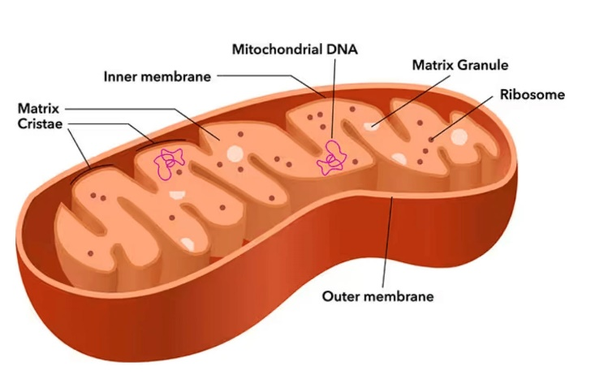

**DR SALMA KHALED BIOLOGY EDUCATOR**

**Vacuole**

* Single, membrane-bound structure that stores substances for the cell.
* **Contractile vacuoles**: Found in freshwater protists (e.g., *Paramecium*, *Amoeba*); pump excess water out of the cell.
* **Large central vacuole**: Found in plant cells and human fat (adipose) cells; used for storage.

**Vesicle**

* Tiny vacuoles.
* Found in many places in cells, including the axon of a neuron (release neurotransmitters into a synapse).

**Plastids *(only in plants and algae; double membrane)***

1. **Chloroplasts**
   * Green due to chlorophyll; sites of photosynthesis.
   * Structure: double outer membrane + inner membrane forming **grana** in the **stroma**.
   * Contain their own DNA and can self-replicate (origin: free-living prokaryotes).
2. **Leucoplasts**
   * Colorless; store starch.
   * Found in roots (e.g., turnips) and tubers (e.g., potatoes).

**DR SALMA KHALED BIOLOGY EDUCATOR**

1. **Chromoplasts**
   * Store carotenoid pigments (red, orange, yellow).
   * Found in carrots, tomatoes, daffodils, etc.
   * Bright pigments in petals attract pollinators.

**Cytoskeleton**

* Complex network of protein filaments throughout cytoplasm.
* Functions: gives shape, enables movement.
* **Two main components**:
  1. **Microtubules**
     + Thick, hollow tubes made of tubulin.
     + Form cilia, flagella, and spindle fibers.
  2. **Microfilaments**
     + Made of actin; support cell shape.
     + Enable:
       - Animal cells to form cleavage furrow during cell division.
       - Amoeba to move via pseudopods.
       - Skeletal muscles to contract by sliding along myosin filaments.

**DR SALMA KHALED BIOLOGY EDUCATOR**

**Centrioles and Centrosomes *(only in animal cells)***

* Located outside nuclear membrane; organize spindle fibers for cell division.
* Plant cells have **microtubule organizing regions** instead.
* Structure:
  + 2 centrioles at right angles = 1 centrosome.
  + Each centriole: 9 triplets of microtubules arranged in a circle.

**Cilia and Flagella**

* Both have the same internal structure, made of microtubules.
* Difference: **Cilia** are short; **Flagella** are long.
* Structure: 9 pairs of microtubules organized around 2 singlet microtubules.

**Cell Wall**

* Not found in animal cells.
* Composition:
  + **Fungi:** Chitin
  + **Plants & Algae:** Cellulose
* In plant cells:
  + Primary cell wall: outside the plasma membrane.
  + Some cells form a secondary cell wall beneath the primary one.

**DR SALMA KHALED BIOLOGY EDUCATOR**

* + When dividing: a thin gluey layer forms between the two cell walls, becoming the **middle lamella**, which keeps daughter cells attached.

**Cytoplasm and Cytosol**

* **Cytoplasm:** Region between the nucleus and plasma membrane.
* **Cytosol:** Semiliquid portion of the cytoplasm.
* In eukaryotic cells: Organelles are suspended in cytosol and move during **cyclosis** (cytoplasmic streaming).

**Cell or Plasma Membrane**

* Selectively permeable: controls what enters and leaves the cell.
* Structure:
  + Phospholipid bilayer with proteins dispersed throughout.
  + Cholesterol molecules: make it less fluid and more stable.
  + External surface: carbohydrate chains for cell-to-cell recognition.

**Proteins in the Membrane**

* Functions:
  + **Enzymes** (e.g., ATP synthetase)
  + **Transport proteins** (e.g., sodium-potassium pump for ion transport)

**DR SALMA KHALED BIOLOGY EDUCATOR**

|  |  |
| --- | --- |
| **Animal Cells** | **Plant Cells** |
| Centrioles and centrosomes | No centrioles or centrosomes |
| No chloroplasts and other plastids | Chloroplasts and other plastids |
| Small vacuoles | Large central vacuoles |
| Plasma membrane only | Cell walls in addition to plasma membrane |
| Lysosomes | No lysosomes |